Linux Basic Assignment.
Name: Shabihul Quadri.

1. Creating and Renaming Files/Directories",
mkdir test_dir
cd test_dir
touch example.txt
mv example.txt renamed_example.txt

Explanation:
- mkdir creates a directory named test_dir.
- touch creates an empty file.
- mv renames the file from example.txt to renamed_example.txt.
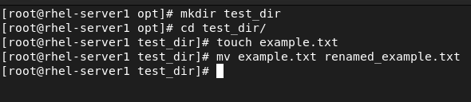
2. Viewing File Contents
cat /etc/passwd
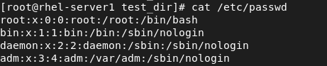
head -n 5 /etc/passwd
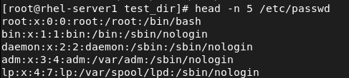
tail -n 5 /etc/passwd
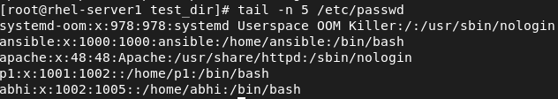
Explanation:
- cat displays the entire file.
- head shows the first 5 lines.
- tail shows the last 5 lines.
3. Searching for Patterns.
grep root /etc/passwd
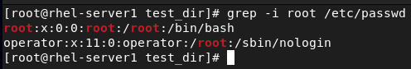
Explanation:
- grep searches for lines containing the word 'root' in the file.
4. Zipping and Unzipping.
Commands:
zip -r test_dir.zip test_dir

unzip test_dir.zip -d unzipped_dir
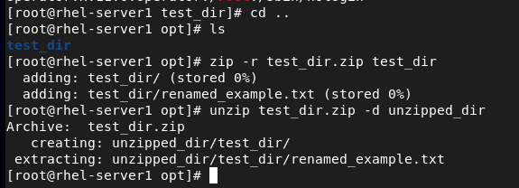
Explanation:
- zip compresses the directory.
- unzip extracts the files into unzipped_dir.
5. Downloading Files,
Command:
wget https://example.com/sample.txt
wget https://www.gnu.org/licenses/gpl-3.0.txt
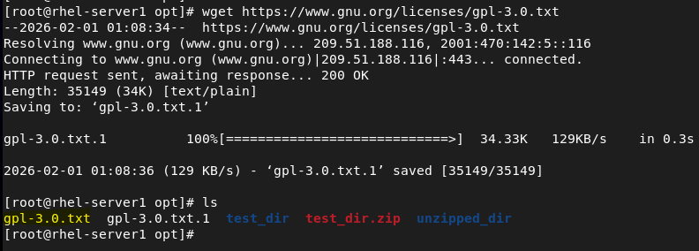
Explanation:
- wget downloads files directly from the internet.
6. Changing Permissions
Commands:
touch secure.txt
chmod 444 secure.txt
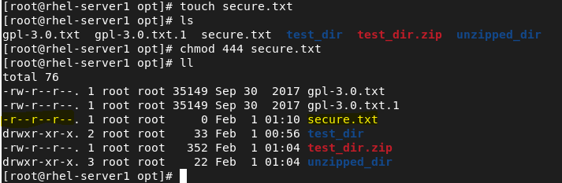
Explanation:
- chmod 444 makes the file read-only for owner, group, and others.

7. Working with Environment Variables",
Command:
export MY_VAR=”Hello, Linux!”
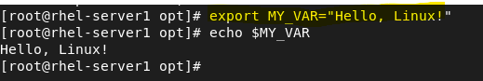

Git: https://github.com/techmsq/Linux-assignment

